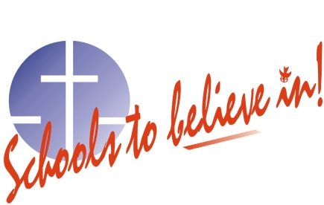

renfrew county catholic district school board

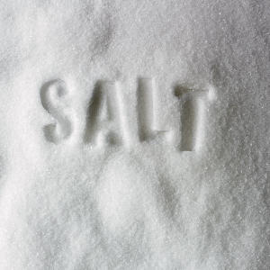
NOTICE

Recent testing of the drinking water has shown that the sodium content of the water at St. Joseph’s Catholic School is 207 mg/L. The recommended level is 20 mg/L.

Please consult your physician with any concerns regarding your sodium intake.

Persons suffering from hypertension or congestive heart disease or those on a sodium-restricted diet should use an alternate source of drinking water.

