renfrew county catholic district school board

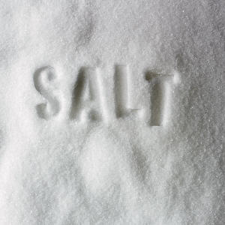
NOTICE

Recent testing of the drinking water has shown that the sodium content of the water at Our Lady of Grace Catholic School is 112 mg/L. The recommended level is 20 mg/L.

Please consult your physician with any concerns regarding your sodium intake.

Persons suffering from hypertension or congestive heart disease or those on a sodium-restricted diet should use an alternate source of drinking water.

